Resolving PackageNotFoundError: Packages missing in current channels

If you are using [Anaconda](https://en.wikipedia.org/wiki/Anaconda_(Python_distribution)) as your choice of Python distribution, the chances are that you have encountered this error message when you try to install a package with conda install command.

There are two ways to fix this issue.

* Use pip install instead of conda install.
* Search the package and install it from the available channel.

The first option is easy. You just type pip install and it will install the package. Make sure to upgrade pip with the command below.

Linux

pip install --upgrade pip

Windows

python -m pip install --upgrade pip

Search the package and install it from non-default channel.

Steps

1. Run the search command

Anaconda search –t conda <package name>

1. The result will show you the channel that has the package. Choose the channel with an appropriate platform.

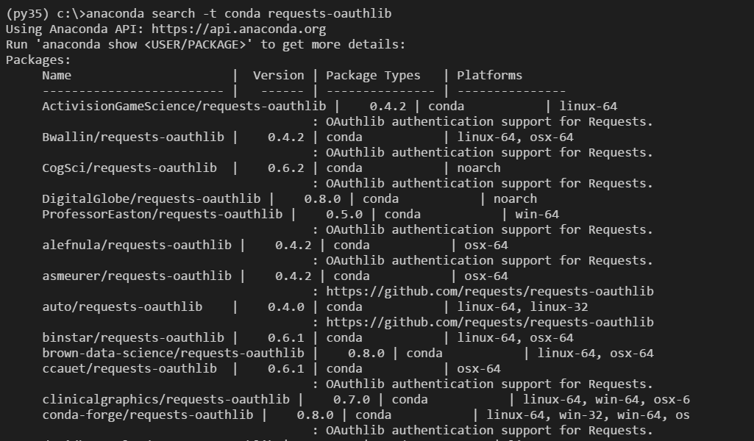

1. From the example above, I will choose the conda-forge channel to install requests-oauthlib with the command below.

conda install -c conda-forge requests-oauthlib

Happy days!